North West Congenital Heart Disease Network
Learning Disability Check List

We are working with the Congenital Heart Disease Network to improve the care and experience of people with learning disabilities, neuro diversity and autism. We have developed this checklist. These are the things we think are important and will help improve the experience of people being admitted to hospital. We would like to visit all the hospitals in our Network and go through this check list with them.

Name of Hospital being visited
Date visited: Click or tap to enter a date.
No | Target | Target | Y/N |  | Comments
1. | 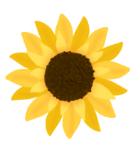  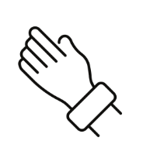 | Do you provide a sunflower lanyard or wristband to let staff know I have additional needs? |   
2. | 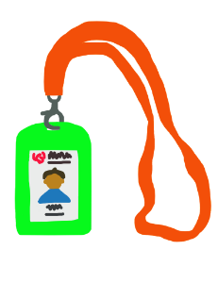 | If I don't want to wear it, can my relative or carer wear it for me?
3. | 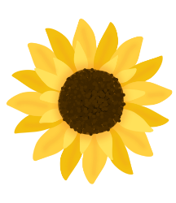 | Can you put a picture of a sunflower on the board by my bed or on the door if I am being looked after in my own room?
4. | 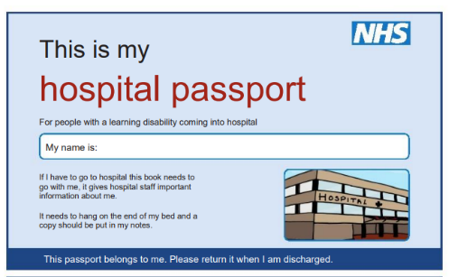 | Is my hospital passport kept up to date?
5. | 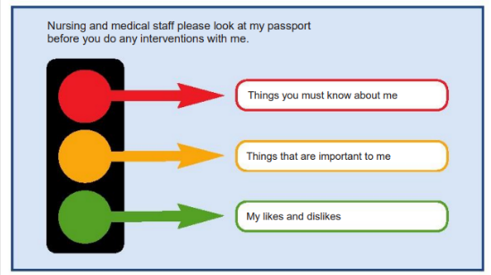 | Is my hospital passport printed out and given to me so I can show it to anyone who might need to read it?
6. | 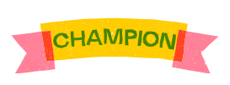  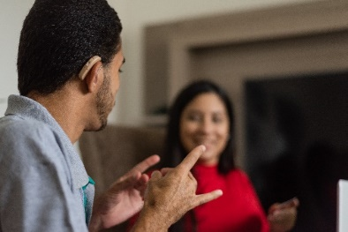 | Do you have a learning disability champion on every ward?
7. | 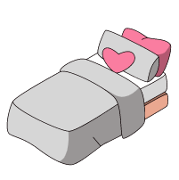  ﻿  ﻿ | Will my family or carer who is staying to look after me have somewhere to sleep?  Will they be able to stay near to me in case I need them?
8. | 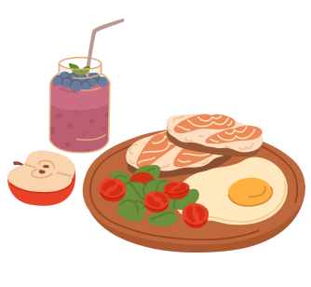 | Will you give food and drink to my family or carer who is staying to look after me?
9. | 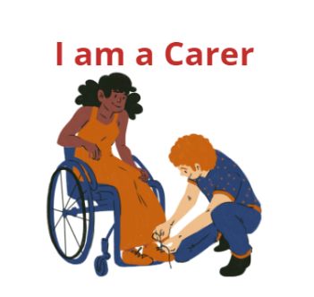 | Do you provide my carer with a card explaining that I need them?  Does this allow them to access food and drinks and be able to go to the toilet?
10. | 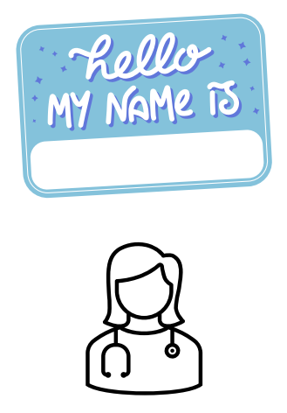 | How will people say hello to me?  Do you use pictures to help so I know what you do and who you are?
11. | 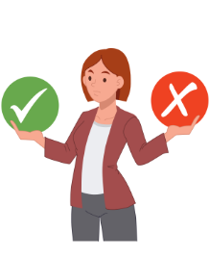 | Will staff help me to make my own decisions before deciding that I can't?  Will they always make a decision that is in my best interest if I can’t make that decision myself?
12. | 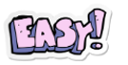  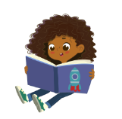 | Do you have easy read versions of your patient leaflets to help me understand?
13. | 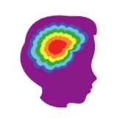  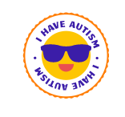 | Is your hospital doing the Oliver McGowan Mandatory training to understand the needs of people with autism?
14. | 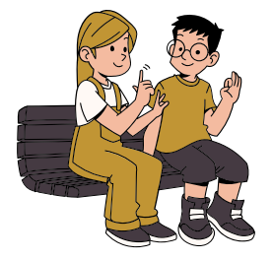 | Are you teaching your learning disability champions how to use Makaton?
15. | 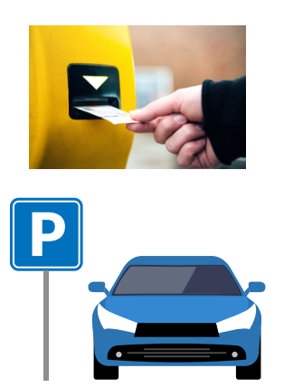 | Do you provide a free parking pass for my family or carer that is staying to help look after me?
16. | 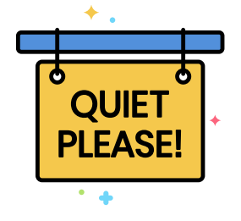 | Do you provide a sensory area for people who need a quiet and calm place to be?
17. | 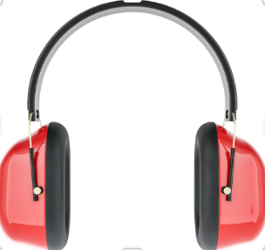 | Do you provide ear defenders or other distraction toys if I need them?
18. | 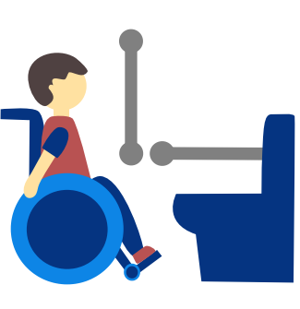 | Do you provide toilets for people with disabilities that includes a changing place?
19. | 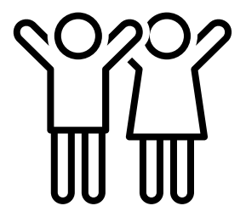 | If my family or carer is not the same sex as me do you provide a separate room so we can stay together overnight?
20. | 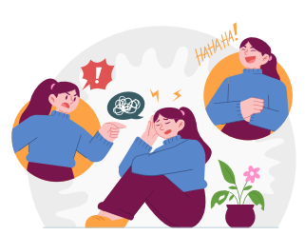 | Will the staff understand that I may need to do things differently?  Will they make reasonable adjustments so I can be cared for in the same way as everyone else?
21. | Please can you share your NHS England Standards Action Plan with us?
22. | Please tell us anything else that you are doing that would be helpful?
23. | You agreed to do these things:
19. | Thank you for listening. We would like to come and visit again in (please select) |  |  | 3 months ☐  6 months ☐  9 months ☐  12 months ☐

